Jack Gallant never set out to create a mind-reading machine. His focus was more prosaic. A computational neuroscientist at the University of California, Berkeley, Dr. Gallant worked for years to improve our understanding of how brains encode information — what regions become active, for example, when a person sees a plane or an apple or a dog — and how that activity represents the object being viewed.
By the late 2000s, scientists could determine what kind of thing a person might be looking at from the way the brain lit up — a human face, say, or a cat. But Dr. Gallant and his colleagues went further. They figured out how to use machine learning to decipher not just the class of thing, but which exact image a subject was viewing. (Which photo of a cat, out of three options, for instance.)
One day, Dr. Gallant and his postdocs got to talking. In the same way that you can turn a speaker into a microphone by hooking it up backward, they wondered if they could reverse engineer the algorithm they’d developed so they could visualize, solely from brain activity, what a person was seeing.
The first phase of the project was to train the AI. For hours, Dr. Gallant and his colleagues showed volunteers in fMRI machines movie clips. By matching patterns of brain activation prompted by the moving images, the AI built a model of how the volunteers’ visual cortex, which parses information from the eyes, worked. Then came the next phase: translation. As they showed the volunteers movie clips, they asked the model what, given everything it now knew about their brains, it thought they might be looking at.
ADVERTISEMENT
Continue reading the main story
The experiment focused just on a subsection of the visual cortex. It didn’t capture what was happening elsewhere in the brain — how a person might feel about what she was seeing, for example, or what she might be fantasizing about as she watched. The endeavor was, in Dr. Gallant’s words, a primitive proof of concept.
- Dig deeper into the moment.
Special offer: Subscribe for $1 a week.
And yet the results, published in 2011, are remarkable.
The reconstructed images move with a dreamlike fluidity. In their imperfection, they evoke expressionist art. (And a few reconstructed images seem downright wrong.) But where they succeed, they represent an astonishing achievement: a machine translating patterns of brain activity into a moving image understandable by other people — a machine that can read the brain.
Dr. Gallant was thrilled. Imagine the possibilities when better brain-reading technology became available? Imagine the people suffering from locked-in syndrome, Lou Gehrig’s disease, the people incapacitated by strokes, who could benefit from a machine that could help them interact with the world?

Editors’ Picks



‘While I Was Away, My Boss Had Flowers Delivered to My Apartment’



Malcolm Gladwell on the Hard Decisions of War



My Boyfriend Has Two Partners. Should I Be His Third?

Continue reading the main story
Video
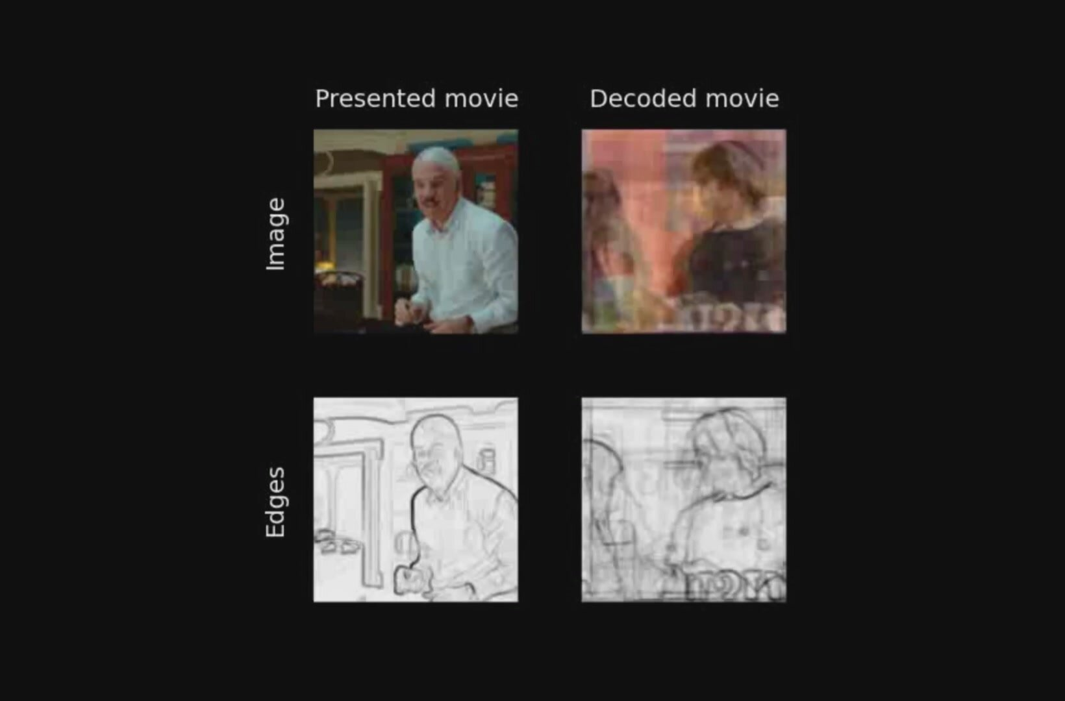
Reconstruction of viewed movies from human brain activity measured by fMRI (Nishimoto et al., 2011)
He was also scared because the experiment showed, in a concrete way, that humanity was at the dawn of a new era, one in which our thoughts could theoretically be snatched from our heads. What was going to happen, Dr. Gallant wondered, when you could read thoughts the thinker might not even be consciously aware of, when you could see people’s memories?
ADVERTISEMENT
Continue reading the main story
“That’s a real sobering thought that now you have to take seriously,” he told me recently.

The ‘Google Cap’
For decades, we’ve communicated with computers mostly by using our fingers and our eyes, by interfacing via keyboards and screens. These tools and the bony digits we prod them with provide a natural limit to the speed of communication between human brain and machine. We can convey information only as quickly (and accurately) as we can type or click.
Voice recognition, like that used by Apple’s Siri or Amazon’s Alexa, is a step toward more seamless integration of human and machine. The next step, one that scientists around the world are pursuing, is technology that allows people to control computers — and everything connected to them, including cars, robotic arms and drones — merely by thinking.
Dr. Gallant jokingly calls the imagined piece of hardware that would do this a “Google cap”: a hat that could sense silent commands and prompt computers to respond accordingly.
The problem is that, to work, that cap would need to be able to see, with some detail, what’s happening in the nearly 100 billion neurons that make up the brain.
Technology that can easily peer through the skull, like the MRI machine, is far too unwieldy to mount on your head. Less bulky technology, like electroencephalogram, or E.E.G., which measures the brain’s electrical activity through electrodes attached to the scalp, doesn’t provide nearly the same clarity. One scientist compares it to looking for the surface ripples made by a fish swimming underwater while a storm roils the lake.
Other methods of “seeing” into the brain might include magnetoencephalography, or M.E.G., which measures magnetic waves emanating outside the skull from neurons firing beneath it; or using infrared light, which can penetrate living tissue, to infer brain activity from changes in blood flow. (Pulse oximeters work this way, by shining infrared light through your finger.)
What technologies will power the brain-computer interface of the future is still unclear. And if it’s unclear how we’ll “read” the brain, it’s even less clear how we’ll “write” to it.
ADVERTISEMENT
Continue reading the main story
This is the other holy grail of brain-machine research: technology that can transmit information to the brain directly. We’re probably nowhere near the moment when you can silently ask, “Alexa, what’s the capital of Peru?” and have “Lima” materialize in your mind.
Even so, solutions to these challenges are beginning to emerge. Much of the research has occurred in the medical realm, where, for years, scientists have worked incrementally toward giving quadriplegics and others with immobilizing neurological conditions better ways of interacting with the world through computers. But in recent years, tech companies — including Facebook, Microsoft and Elon Musk’s Neuralink — have begun investing in the field.
Some scientists are elated by this infusion of energy and resources. Others worry that as this tech moves into the consumer realm, it could have a variety of unintended and potentially dangerous consequences, from the erosion of mental privacy to the exacerbation of inequality.
Rafael Yuste, a neurobiologist at Columbia University, counts two great advances in computing that have transformed society: the transition from room-size mainframe computers to personal computers that fit on a desk (and then in your lap), and the advent of mobile computing with smartphones in the 2000s. Noninvasive brain-reading tech would be a third great leap, he says.
“Forget about the Covid crisis,” Dr. Yuste told me. “What’s coming with this new tech can change humanity.”

Dear Brain
Not many people will volunteer to be the first to undergo a novel kind of brain surgery, even if it holds the promise of restoring mobility to those who’ve been paralyzed. So when Robert Kirsch, the chairman of biomedical engineering at Case Western Reserve University, put out such a call nearly 10 years ago, and one person both met the criteria and was willing, he knew he had a pioneer on his hands.

